# Startup and Observing Modes

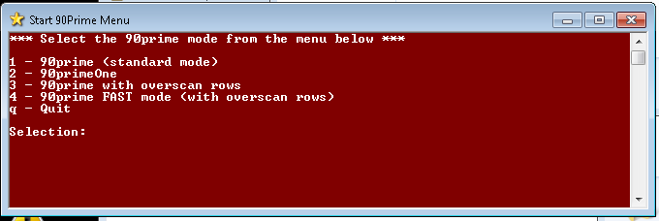The *AzCam* code for 90prime is now started from a desktop icon named “Start 90Prime Menu”. It opens a window (shown below) with a menu of options to support the new observing modes needed by the DESI survey program.

Press the appropriate menu number (or ‘q’ to quit):

* Option 1 is the normal 90prime mode.
* Option 2 is the normal 90primeOne mode.
* Option 3 is a new mode which includes 20 ROWS of overscan in each image section.
* Option 4 is a new mode with which reads out faster and has the extra 20 overscan rows.

The standard readout time for 90prime and 90primeOne is about 30 seconds. The new fast mode is 21 seconds. ***Note that the new fast mode has not yet been calibrated in the lab for noise and gain.***

# *PrimeFocus* Class

A new python software class has been defined which allows custom software code to be developed and executed for 90prime which does not affect other AzCam systems. This class creates the “**primefocus**” object which has various commands and parameters and is called from the *AzCamConsole* command line (usually the blue window). This in an ongoing development, but the “**primefocus.Observe()**” command is the important one for the DESI survey. Use for the DESI survey, use **primefocus.Observe()** instead of “Run Observe”. “Run Observe” will still work as in the past in case there are issues.

## **primefocus** object commands:

* **primefocus.Observe()**:  
  This code is similar to the old Observe script, but is optimized for speed. Most importantly, it will move the telescope to the next field during readout of the current field. The output log file is slight different due to the way the code works but can be modified as the code evolves. The code parses the entire observing script before staring and displays the commands to be executed. To run the command just type *primefocus.Observe()* in the *AzCamConsole* window.
* **primefocus.Help()**:  
  Displays help text for the primefocus object.

## **primefocus** object parameters:

* **primefocus.NumberCycles**: Number of the times the script will be run (default 1). Change this by typing, for example, *primefocus.NumberCycles=2***.**
* **primefocus.Confirm:** Flag to wait for user to press return after display of all commands to be executed (default True).
* **primefocus.MoveTelescopeDuringReadout:** Flag to move telescope to next field during readout of current field (default True).
* **primefocus.DummyMode:** (Debugging only) used for skip some actions (default False).

# Technical Notes

The focal plane temperature controller is now initialized when *AzCam* starts so it must be powered on first. At startup, a command is now sent to the controller to set “PID” mode as well as start the temperature closed-loop control. An ID string is also read back and reported to verify communication is working properly. These changes are to address issues with the controller “resetting” itself.

The new observing mode which allows moving the telescope during readout runs in an asynchronous mode which requires further work to properly return error messages. Normally *AzCam* waits for a return message and stops if there is an error. In the new mode this is not currently possible and some errors may silently occur. Make sure images are being written to disk!

The FITS image keywords supporting the extra overscan rows may not be correct, this has not yet been checked.

The telescope movement timeout of 20 second for a scripted move has been removed.